Architecture Migration

🌟 Definition
# Source: AI Source: Provided by: [Data Path: Persons Table -> ID Column: 1, Name_En Column: Motasem Essam] -> From: [ChatGPT] on [6/7/2026]
API Architecture Migration is the process of changing the underlying architectural style or design of an API while preserving or improving its business functionality.
Instead of simply changing API versions or providers, architecture migration changes how the API is built, organized, and communicates.

🎯 Purpose
# Source: AI Source: Provided by: [Data Path: Persons Table -> ID Column: 1, Name_En Column: Motasem Essam] -> From: [ChatGPT] on [6/7/2026]
Organizations perform API architecture migration to:
- Improve scalability
- Improve performance
- Simplify maintenance
- Support cloud-native systems
- Increase flexibility
- Modernize legacy APIs
- Enable faster development

🧠 Simple Definition
# Source: AI Source: Provided by: [Data Path: Persons Table -> ID Column: 1, Name_En Column: Motasem Essam] -> From: [ChatGPT] on [6/7/2026]
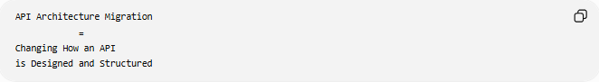
API Architecture Migration
=
Changing How an API
is Designed and Structured

📚 What is API Architecture?
# Source: AI Source: Provided by: [Data Path: Persons Table -> ID Column: 1, Name_En Column: Motasem Essam] -> From: [ChatGPT] on [6/7/2026]
API architecture defines:
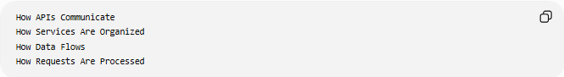
How APIs Communicate
How Services Are Organized
How Data Flows
How Requests Are Processed
Examples:
- REST Architecture
- SOAP Architecture
- GraphQL Architecture
- Microservices APIs
- Event-Driven APIs

🔍 Basic Example
# Source: AI Source: Provided by: [Data Path: Persons Table -> ID Column: 1, Name_En Column: Motasem Essam] -> From: [ChatGPT] on [6/7/2026]
Before
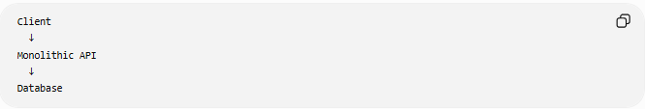
Client
↓
Monolithic API
↓
Database

After
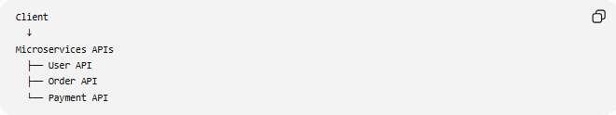
Client
↓
Microservices APIs
├── User API
├── Order API
└── Payment API
The business functionality remains the same, but the architecture changes.

🏗️ Common API Architecture Migrations

1️⃣ Monolithic API → Microservices APIs
# Source: AI Source: Provided by: [Data Path: Persons Table -> ID Column: 1, Name_En Column: Motasem Essam] -> From: [ChatGPT] on [6/7/2026]
Before
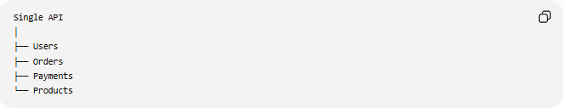
Single API
│
├── Users
├── Orders
├── Payments
└── Products

After
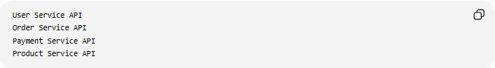
User Service API
Order Service API
Payment Service API
Product Service API
Benefits:
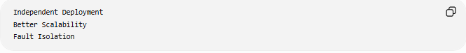
Independent Deployment
Better Scalability
Fault Isolation

2️⃣ SOAP → REST
# Source: AI Source: Provided by: [Data Path: Persons Table -> ID Column: 1, Name_En Column: Motasem Essam] -> From: [ChatGPT] on [6/7/2026]
Before
SOAP API
Uses:
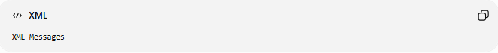
XML Messages

After
REST API
Uses:
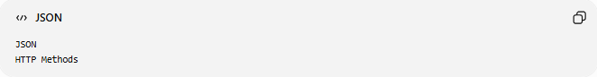
JSON
HTTP Methods
Benefits:
Simpler Development
Better Web Support

3️⃣ REST → GraphQL
# Source: AI Source: Provided by: [Data Path: Persons Table -> ID Column: 1, Name_En Column: Motasem Essam] -> From: [ChatGPT] on [6/7/2026]
Before
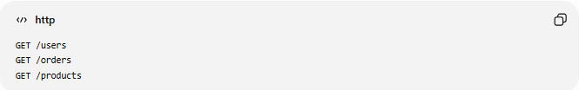
GET /users
GET /orders
GET /products

After
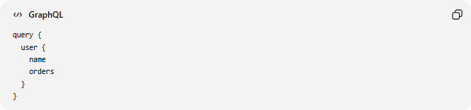
query {
user {
name
orders
}
}
Benefits:
Flexible Queries
Reduced Data Transfer

4️⃣ Synchronous API → Event-Driven API
# Source: AI Source: Provided by: [Data Path: Persons Table -> ID Column: 1, Name_En Column: Motasem Essam] -> From: [ChatGPT] on [6/7/2026]
Before
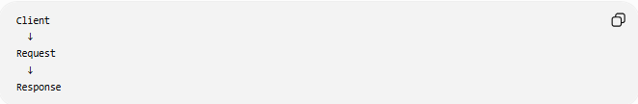
Client
↓
Request
↓
Response

After
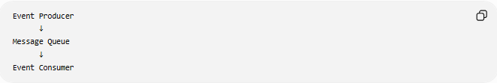
Event Producer
↓
Message Queue
↓
Event Consumer
Benefits:
Asynchronous Processing
Better Scalability

🛠️ Real-World Example
# Source: AI Source: Provided by: [Data Path: Persons Table -> ID Column: 1, Name_En Column: Motasem Essam] -> From: [ChatGPT] on [6/7/2026]
Before Migration
An e-commerce platform exposes one large API.
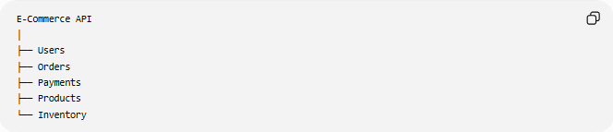
E-Commerce API
│
├── Users
├── Orders
├── Payments
├── Products
└── Inventory
Problems:
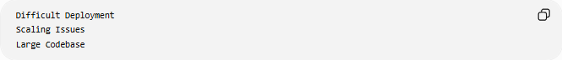
Difficult Deployment
Scaling Issues
Large Codebase

Migration
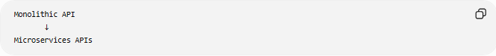
Monolithic API
↓
Microservices APIs

After Migration
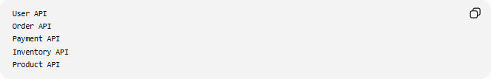
User API
Order API
Payment API
Inventory API
Product API
Benefits:
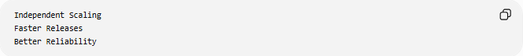
Independent Scaling
Faster Releases
Better Reliability

🔄 Architecture Migration Lifecycle
# Source: AI Source: Provided by: [Data Path: Persons Table -> ID Column: 1, Name_En Column: Motasem Essam] -> From: [ChatGPT] on [6/7/2026]
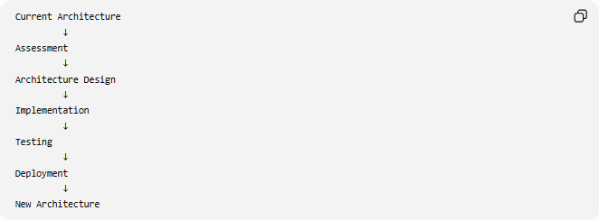
Current Architecture
↓
Assessment
↓
Architecture Design
↓
Implementation
↓
Testing
↓
Deployment
↓
New Architecture

📦 Common Architectural Transformations
# Source: AI Source: Provided by: [Data Path: Persons Table -> ID Column: 1, Name_En Column: Motasem Essam] -> From: [ChatGPT] on [6/7/2026]
Monolith → Microservices
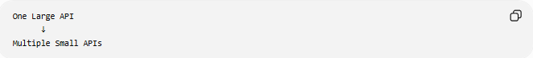
One Large API
↓
Multiple Small APIs

SOAP → REST
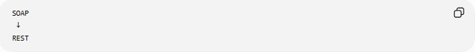
SOAP
↓
REST

REST → GraphQL
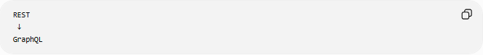
REST
↓
GraphQL

Request/Response → Event-Driven
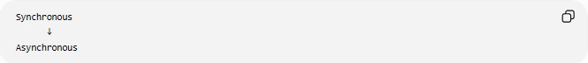
Synchronous
↓
Asynchronous

On-Prem APIs → Cloud-Native APIs
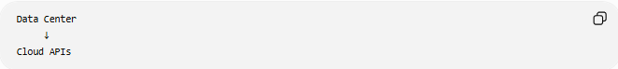
Data Center
↓
Cloud APIs

🌍 Example: SOAP to REST Migration
# Source: AI Source: Provided by: [Data Path: Persons Table -> ID Column: 1, Name_En Column: Motasem Essam] -> From: [ChatGPT] on [6/7/2026]
Before
SOAP Request:
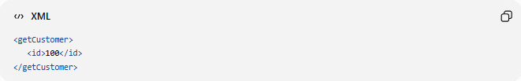
<getCustomer>
<id>100</id>
</getCustomer>

After
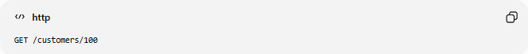
REST Request:
GET /customers/100
Response:
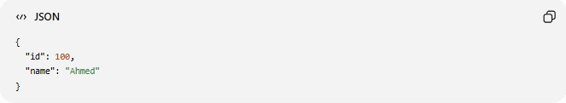
{
"id": 100,
"name": "Ahmed"
}
Benefits:
Smaller Payloads
Simpler Integration

⚠️ Common Challenges
# Source: AI Source: Provided by: [Data Path: Persons Table -> ID Column: 1, Name_En Column: Motasem Essam] -> From: [ChatGPT] on [6/7/2026]
Large Code Changes
Applications often require major updates.

Data Compatibility
Different architectures may use different data formats.
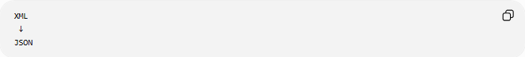
Example:
XML
↓
JSON

Service Coordination
Microservices require communication between multiple services.

Monitoring Complexity
More services often mean more monitoring requirements.

Testing Effort
Every integration must be validated.

✅ Benefits
# Source: AI Source: Provided by: [Data Path: Persons Table -> ID Column: 1, Name_En Column: Motasem Essam] -> From: [ChatGPT] on [6/7/2026]
Better Scalability
Scale Individual Services

Faster Development
Independent Teams
Independent Releases

Improved Reliability
One Service Failure
Does Not Stop Entire System

Better Cloud Compatibility
Cloud-Native Design

Improved Performance
Optimized Data Flow

📊 Architecture Migration vs API Version Migration
# Source: AI Source: Provided by: [Data Path: Persons Table -> ID Column: 1, Name_En Column: Motasem Essam] -> From: [ChatGPT] on [6/7/2026]
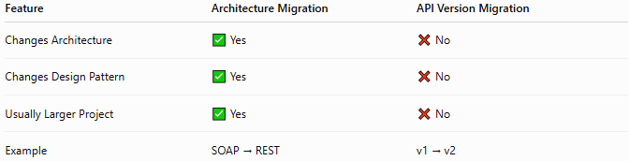
Feature | Architecture Migration | API Version Migration
Changes Architecture | ✅ Yes | ❌ No
Changes Design Pattern | ✅ Yes | ❌ No
Usually Larger Project | ✅ Yes | ❌ No
Example | SOAP → REST | v1 → v2

API Version Migration
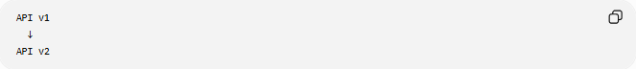
API v1
↓
API v2

Architecture Migration
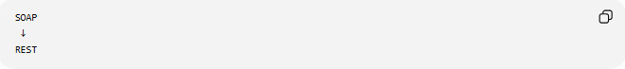
SOAP
↓
REST
or
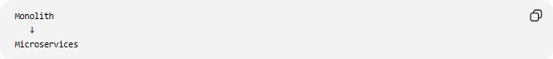
Monolith
↓
Microservices

🛠️ Common Technologies
# Source: AI Source: Provided by: [Data Path: Persons Table -> ID Column: 1, Name_En Column: Motasem Essam] -> From: [ChatGPT] on [6/7/2026]
REST APIs
- REST
SOAP APIs
- SOAP
GraphQL APIs
- GraphQL
Event Streaming
- Apache Kafka
API Gateways
- Kong Gateway
- Apigee

🧠 Simple Analogy
# Source: AI Source: Provided by: [Data Path: Persons Table -> ID Column: 1, Name_En Column: Motasem Essam] -> From: [ChatGPT] on [6/7/2026]
Imagine a restaurant kitchen.
Before
One Large Kitchen
All Chefs Work Together

After
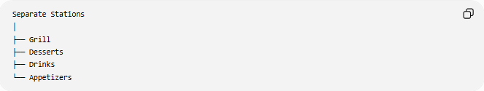
Separate Stations
│
├── Grill
├── Desserts
├── Drinks
└── Appetizers
The restaurant serves the same food, but the kitchen is organized differently for efficiency.
API architecture migration works the same way:
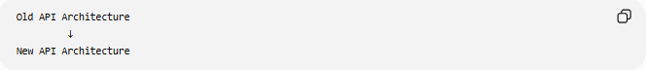
Old API Architecture
↓
New API Architecture
while delivering the same business functionality.

🧭 Summary
# Source: AI Source: Provided by: [Data Path: Persons Table -> ID Column: 1, Name_En Column: Motasem Essam] -> From: [ChatGPT] on [6/7/2026]
API Architecture Migration is a type of API migration that changes the fundamental design and structure of an API. Common examples include SOAP → REST, REST → GraphQL, Monolithic API → Microservices APIs, and Synchronous → Event-Driven APIs. Unlike API version migration, which updates an API version, architecture migration transforms how the API is built and operates. Its primary goals are improving scalability, maintainability, flexibility, cloud readiness, and long-term system performance.

